Kevin Abrahams

Java Side Project

Tic Tac Toe Game

In this project, I have created a Tic Tac Toe game using Java GUI. For this game, there are three things you must check for to discover if either player one or two has won the game, the rows, the columns, and the diagonals. There are 3 rows that can be won in either of two ways (with three matching x’s or three matching circles), 3 columns that can be won in either of two ways (with three matching x’s or three matching circles), and 2 diagonals that can be won in either of two ways (with three matching x’s or three matching circles).

Player 1 has the X symbol, and Player 2 has the circle symbol. Each player uses the command line/console to enter in their move, designated by a row and column separated by a single space.

In this document, I provide three example game sequences, the first showing player 1 winning with a diagonal, the second showing player 2 winning with a column, and the third showing what happens if neither player has won, which causes the game to result in a tie.

This project/program assumes the user enters valid input when picking a move or grid.

**Game Sequence 1 (Player 1 winning with a diagonal):**

Original game window appears:

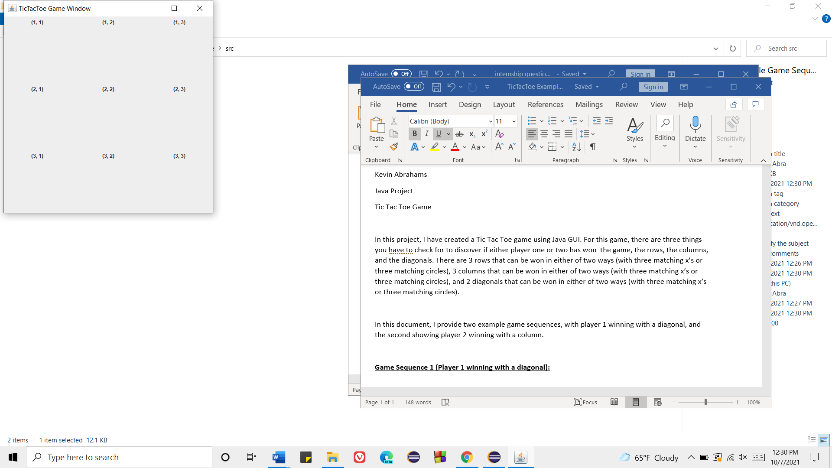

Player 1 chooses grid (1, 1); thus, an X takes that slot:

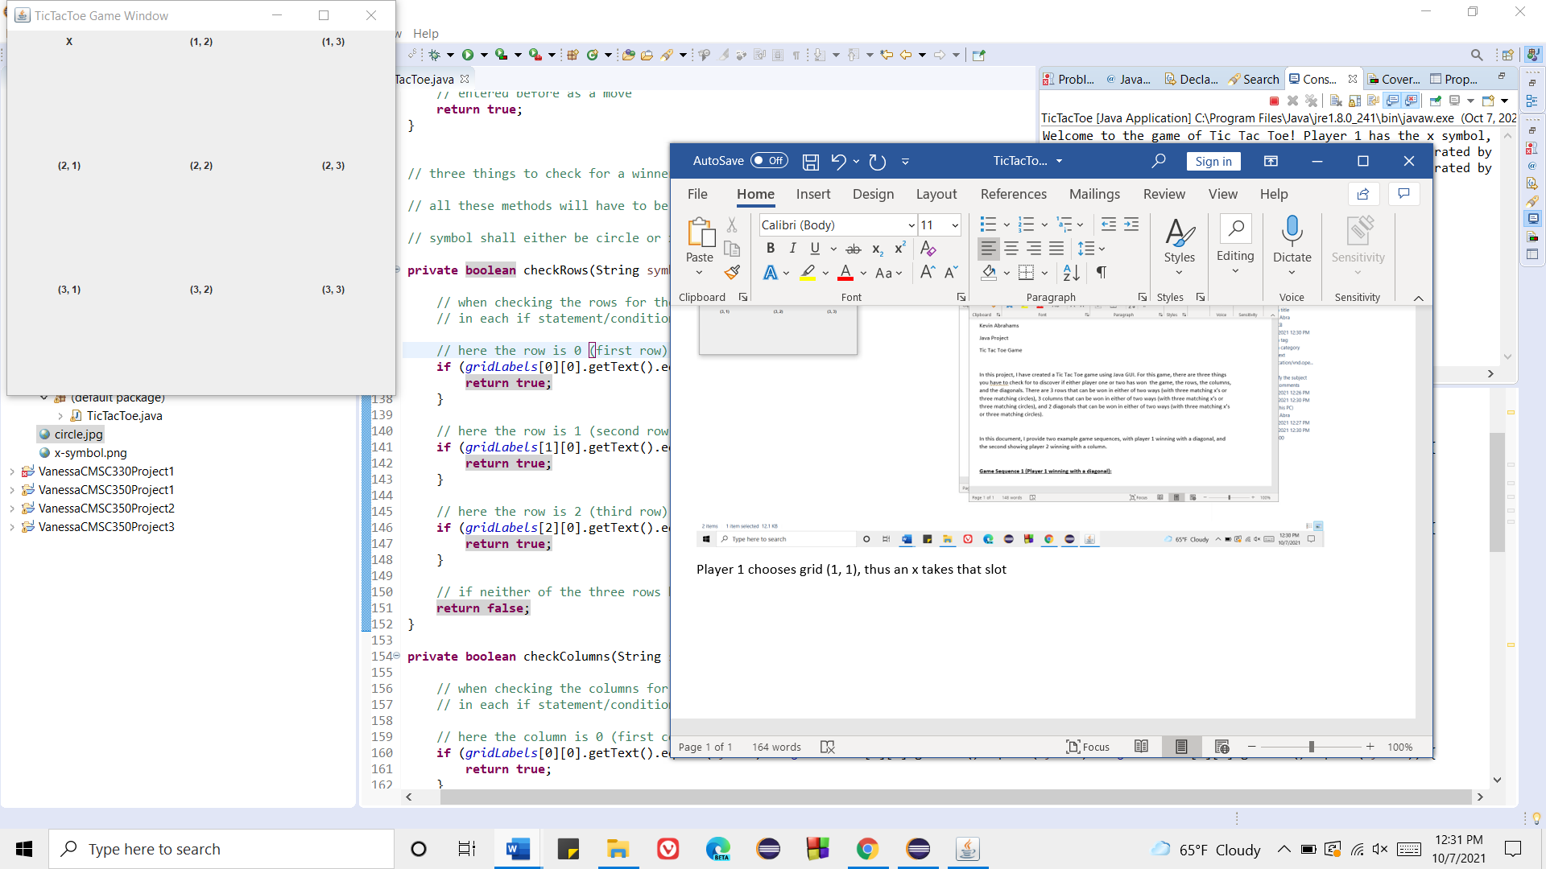

Player 2 chooses grid (1, 2); thus, a circle takes that slot

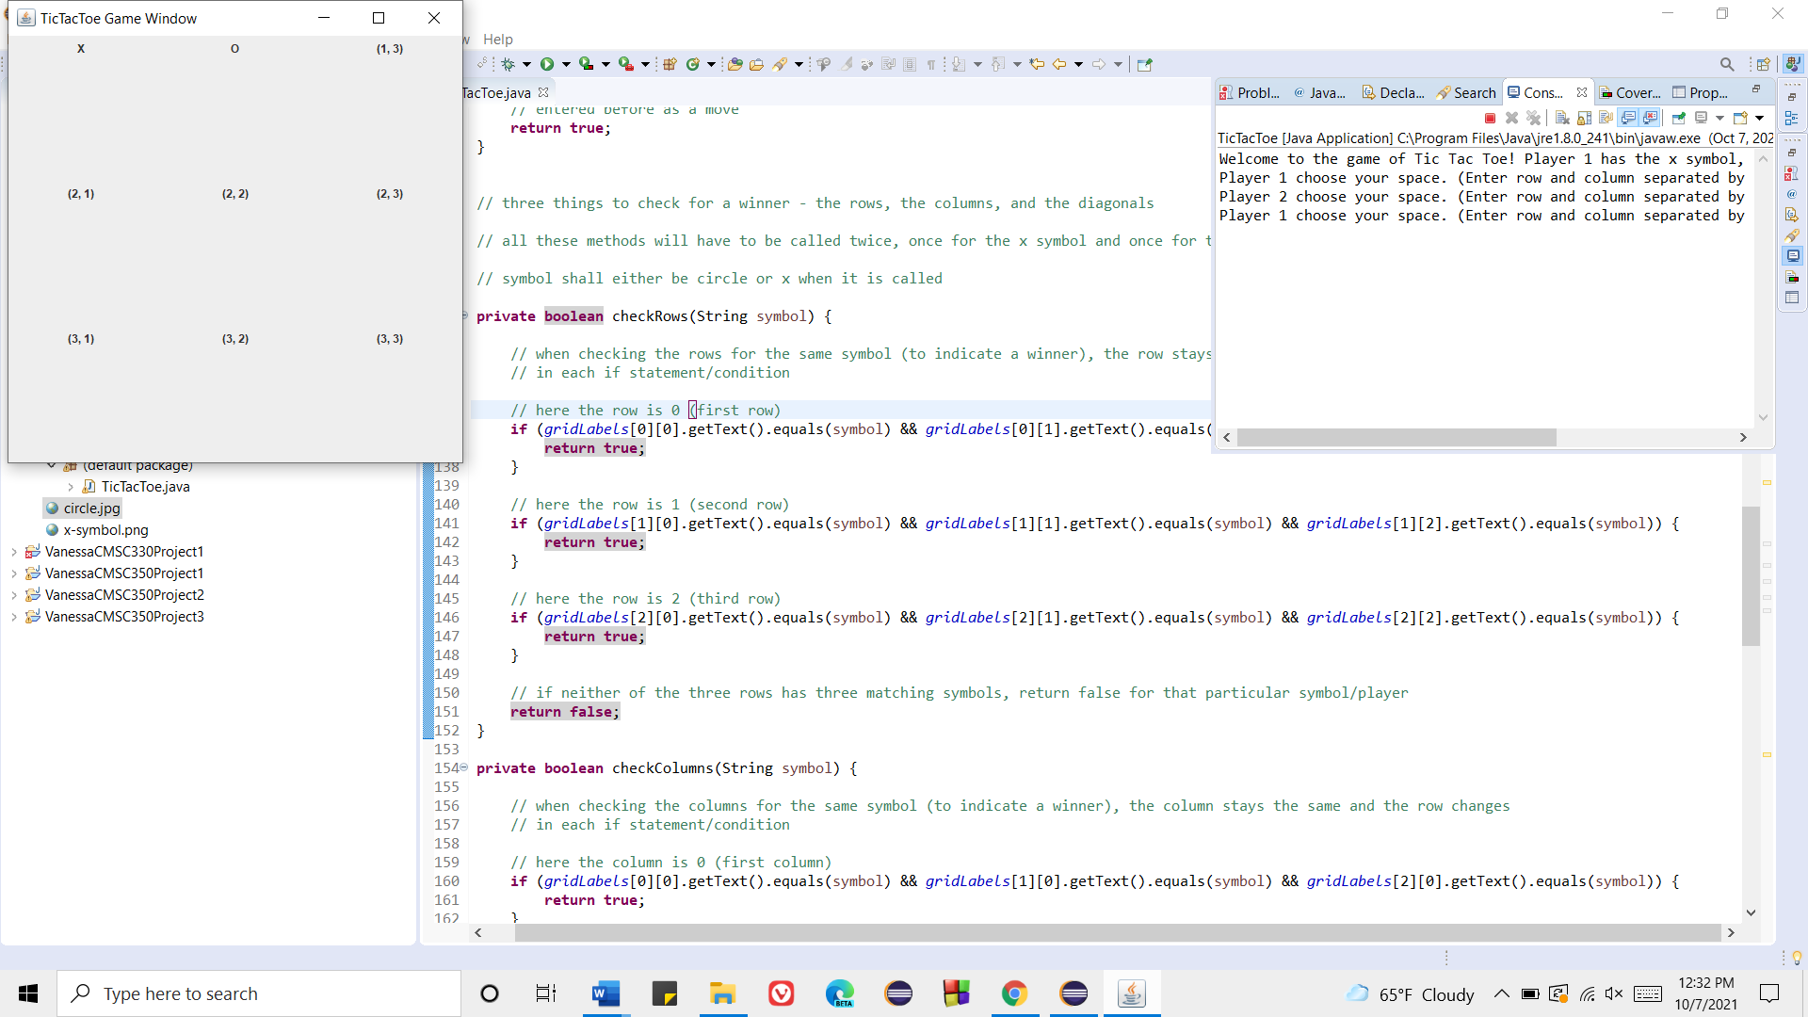

Player 1 chooses grid (2,2); thus, an X takes that slot:

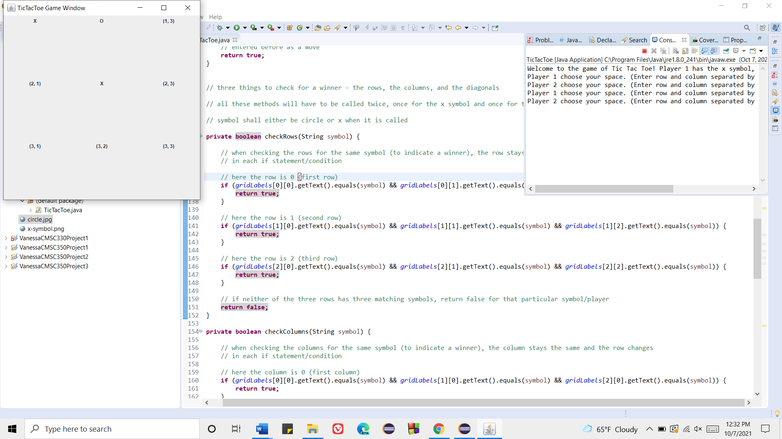

Player 2 chooses grid (2, 3); thus, a circle takes that slot:

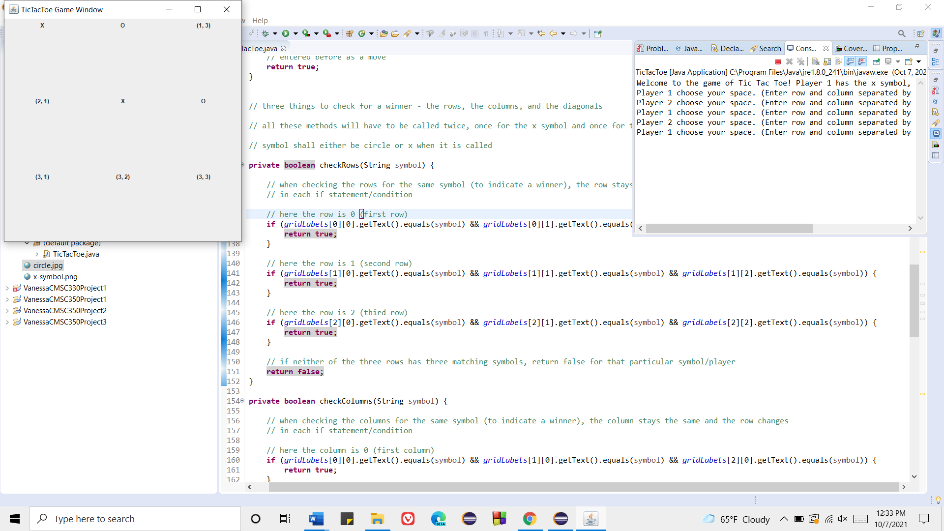

Player 1 chooses grid (3, 3); thus, an x takes that slot, and player 1 wins the game. The game ends, and the program terminates.

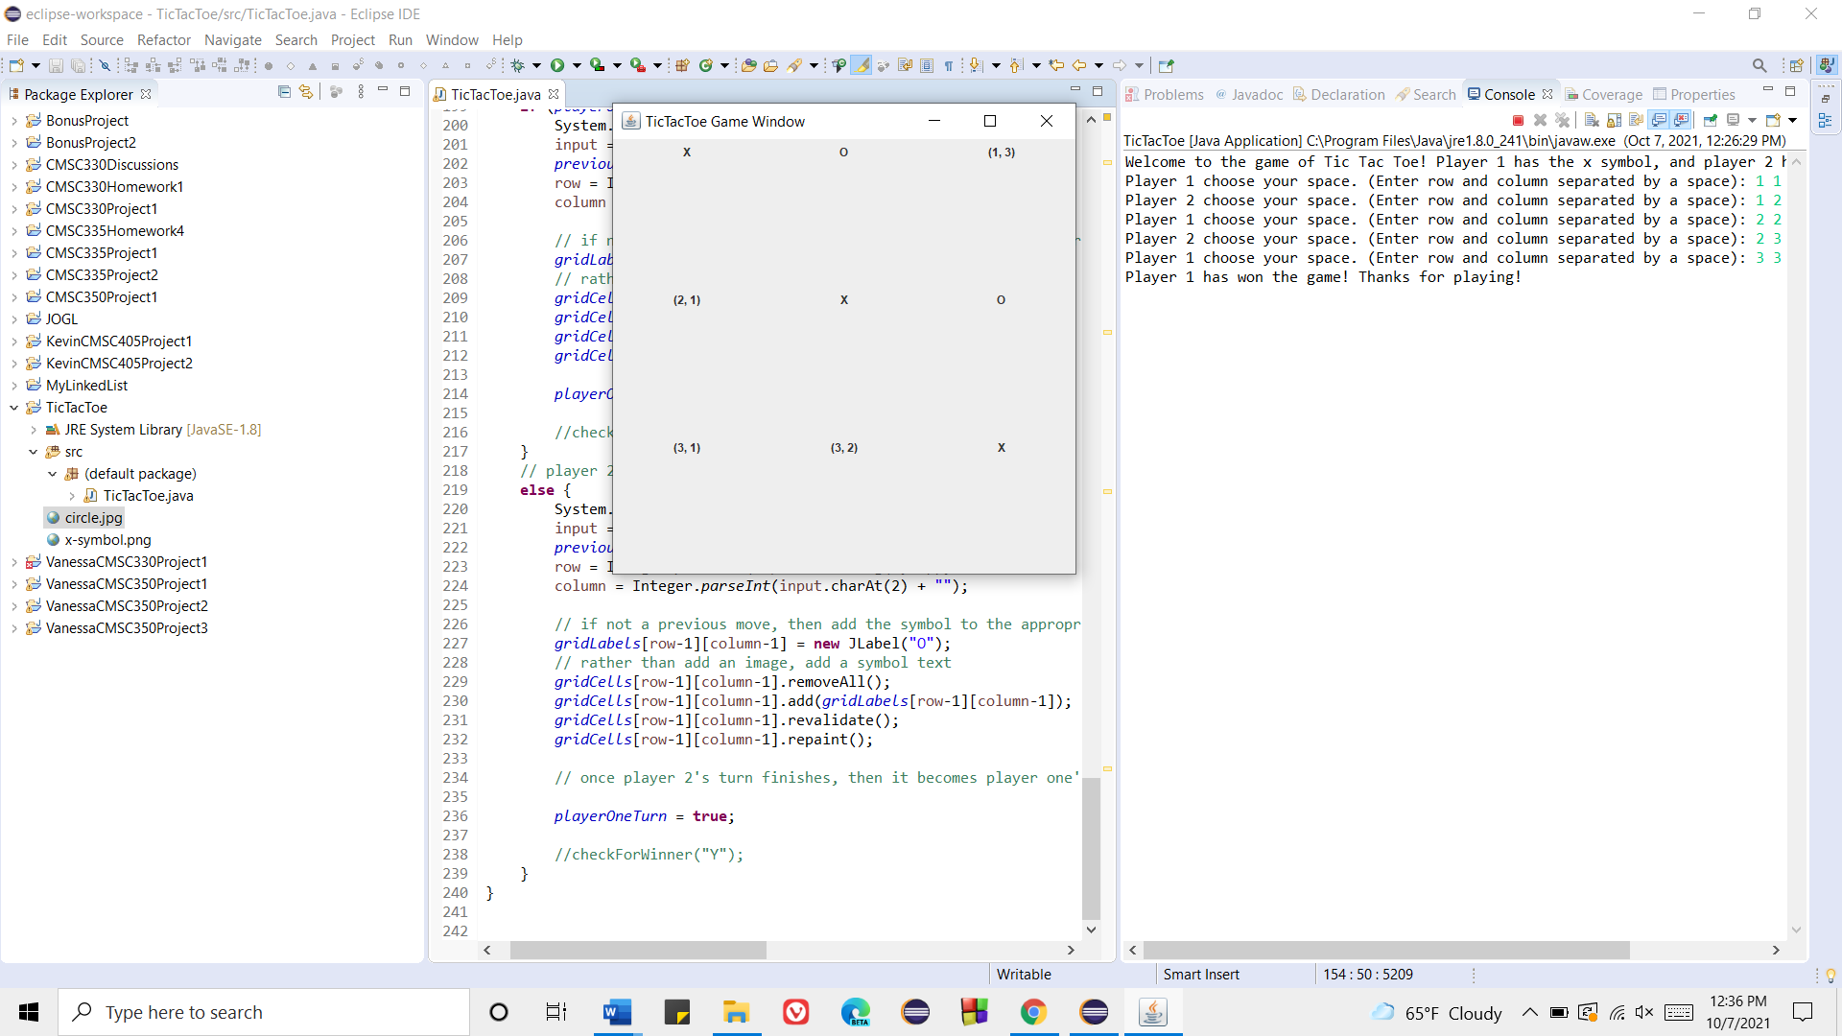

**Game Sequence 2 (Player 2 winning with a column):**

Original game window appears:



Player 1 chooses grid (2, 1); thus, an X takes that slot:

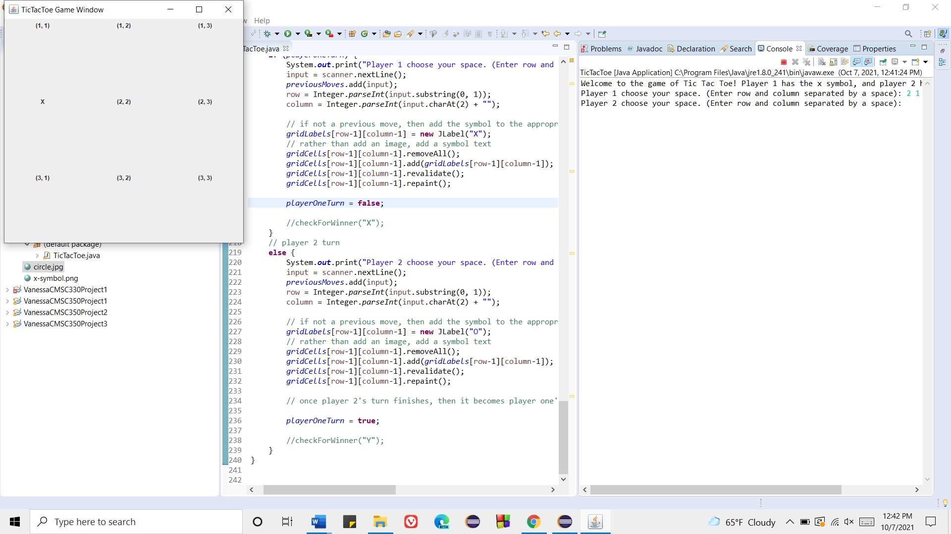

Player 2 chooses grid (1, 3); thus, a circle takes that slot:

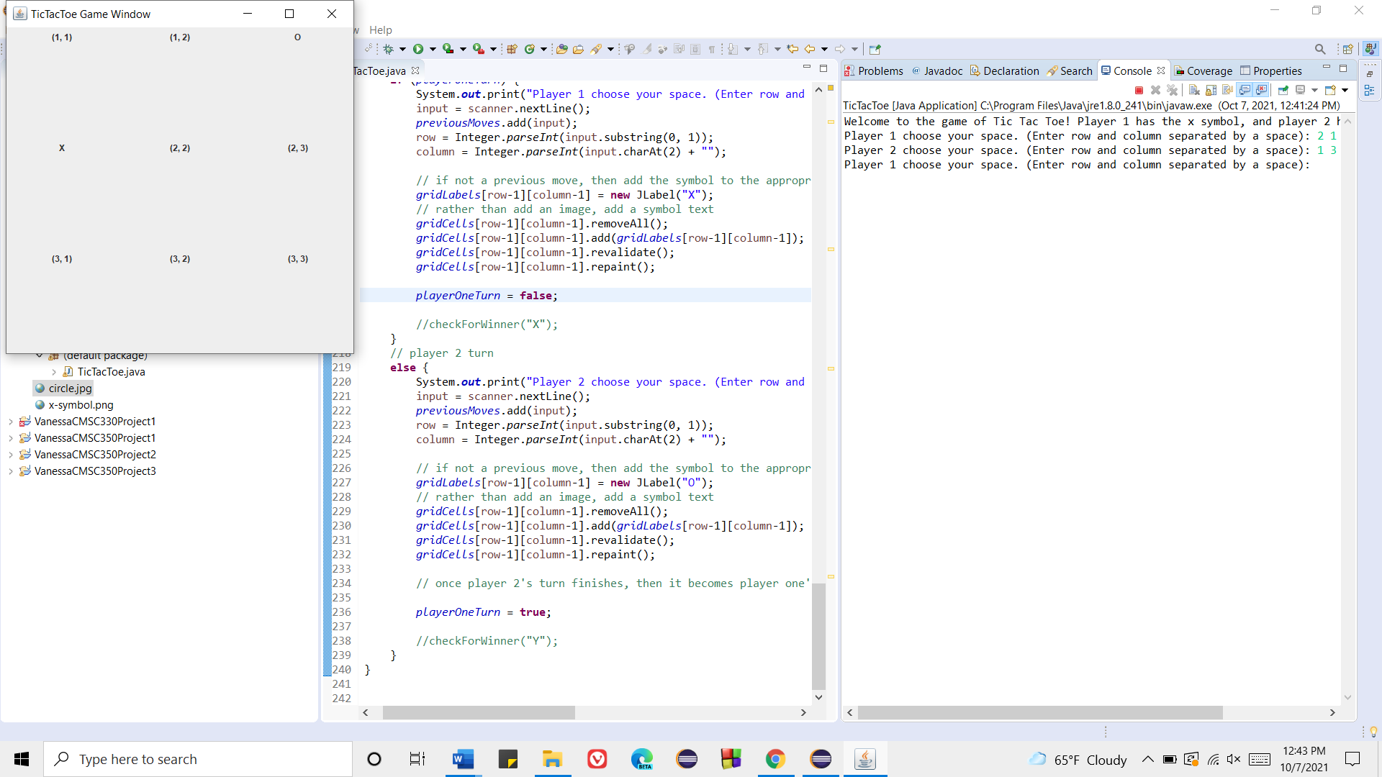

Player 1 chooses grid (2, 2); thus, an X takes that slot:

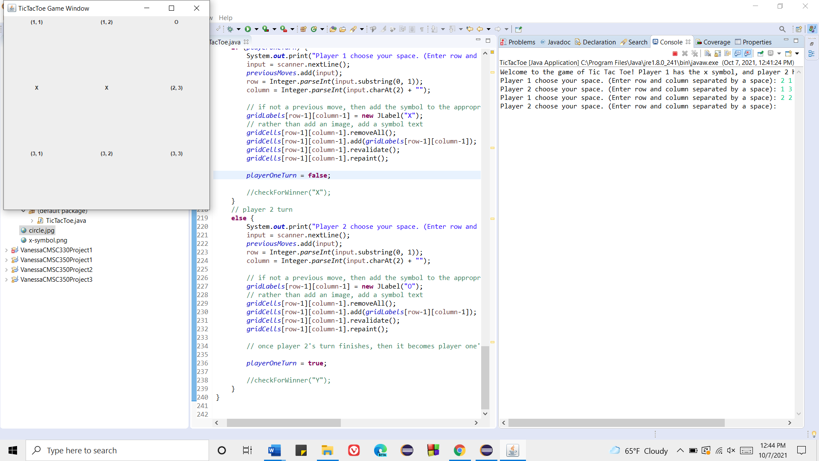

Player 2 chooses grid (2, 3); thus, a circle takes that slot:

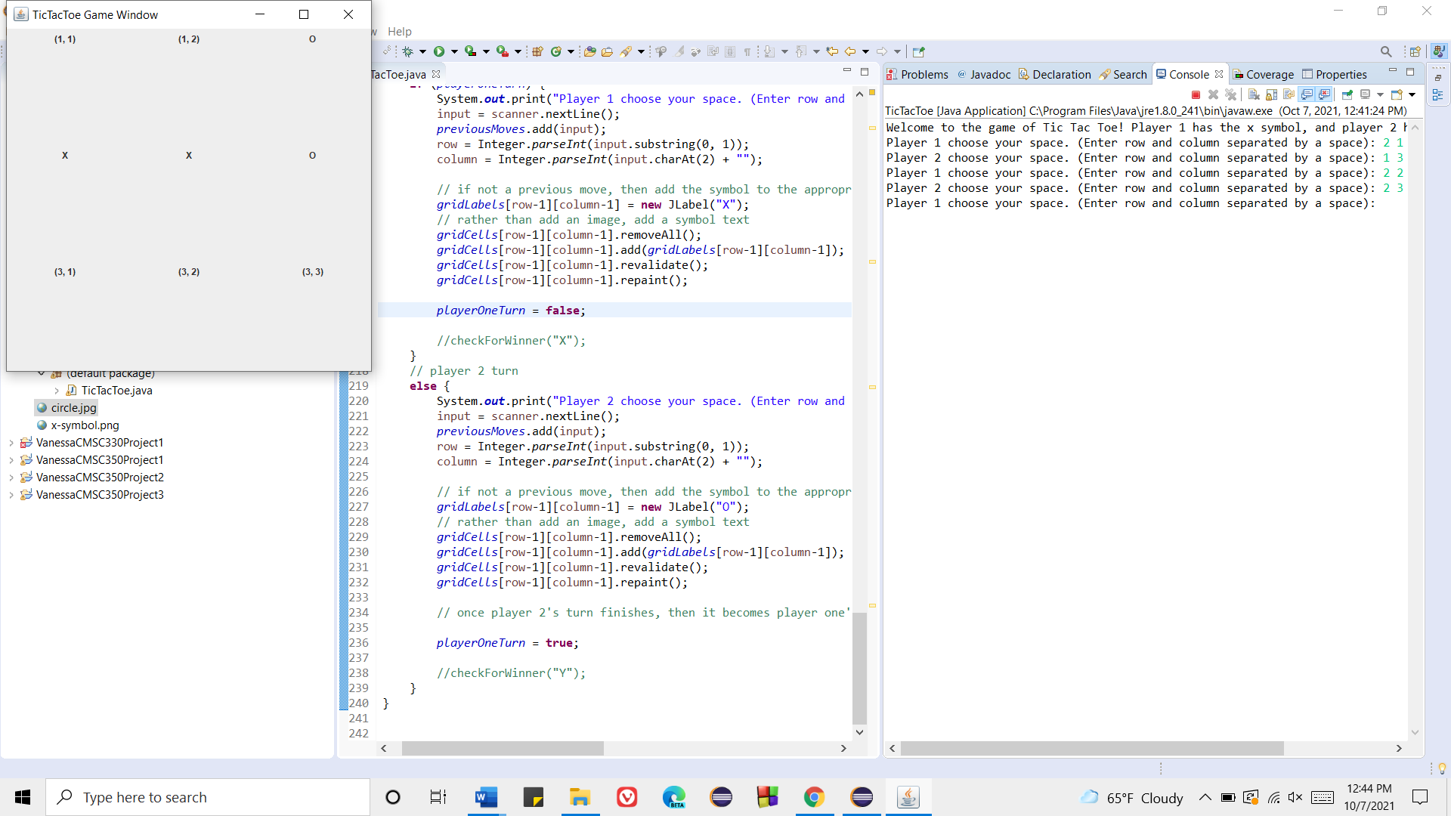

Player 1 chooses grid (1, 2); thus, an X takes that slot:

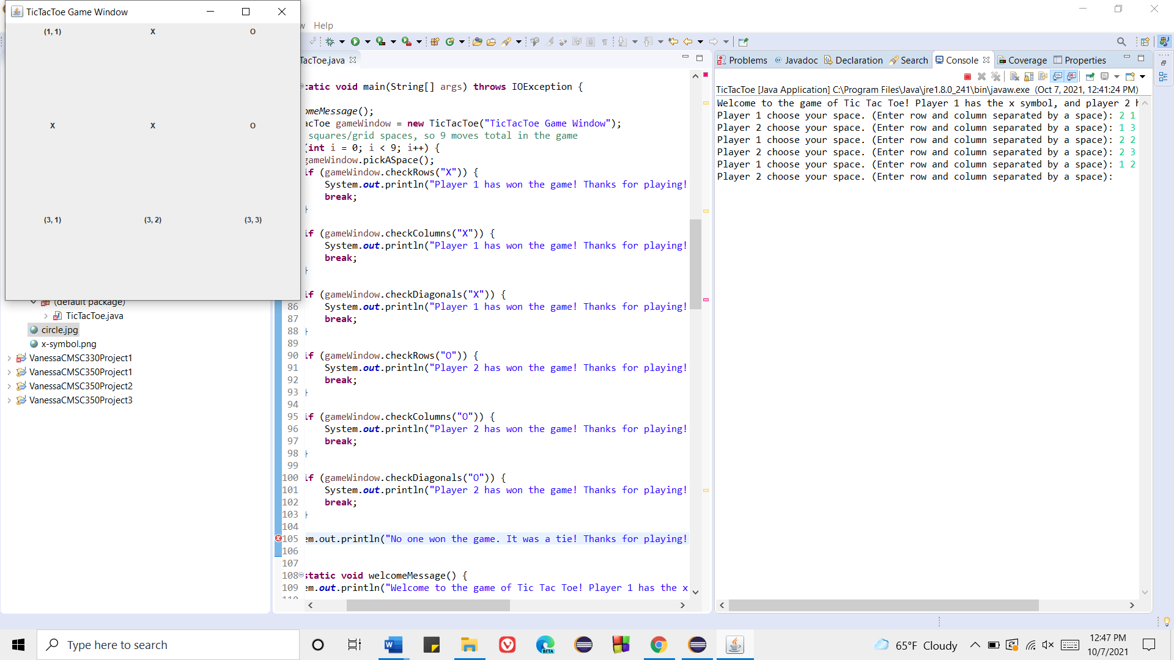

Player 2 chooses grid (3, 3); thus, a circle takes that slot, and player 2 wins the game. The game ends, and the program terminates.

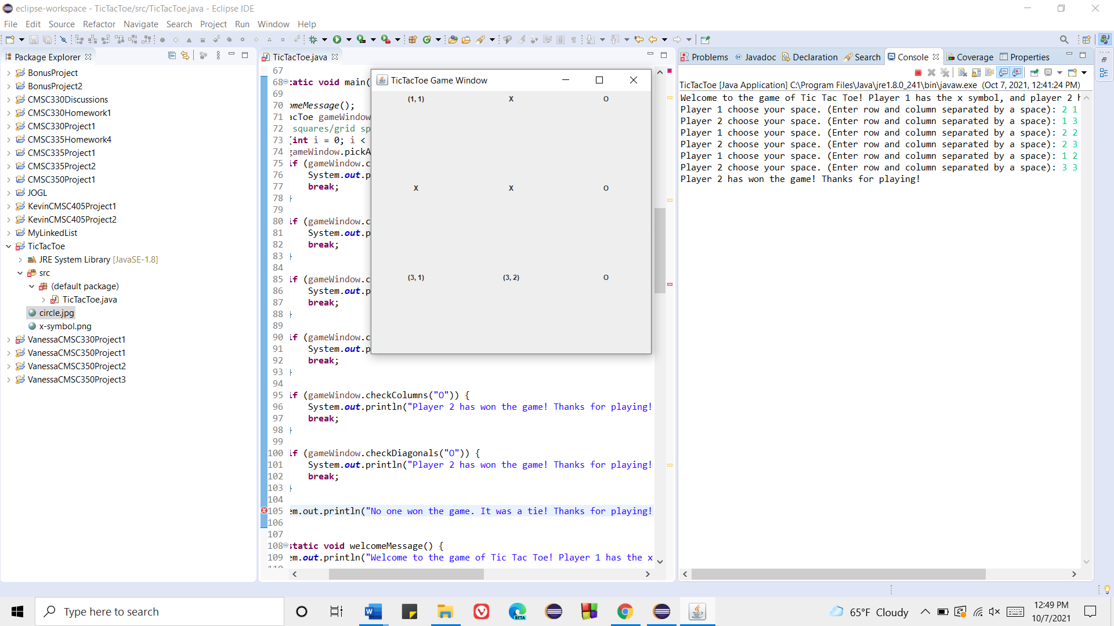

**Game Sequence 3 (No one has won - Tie):**

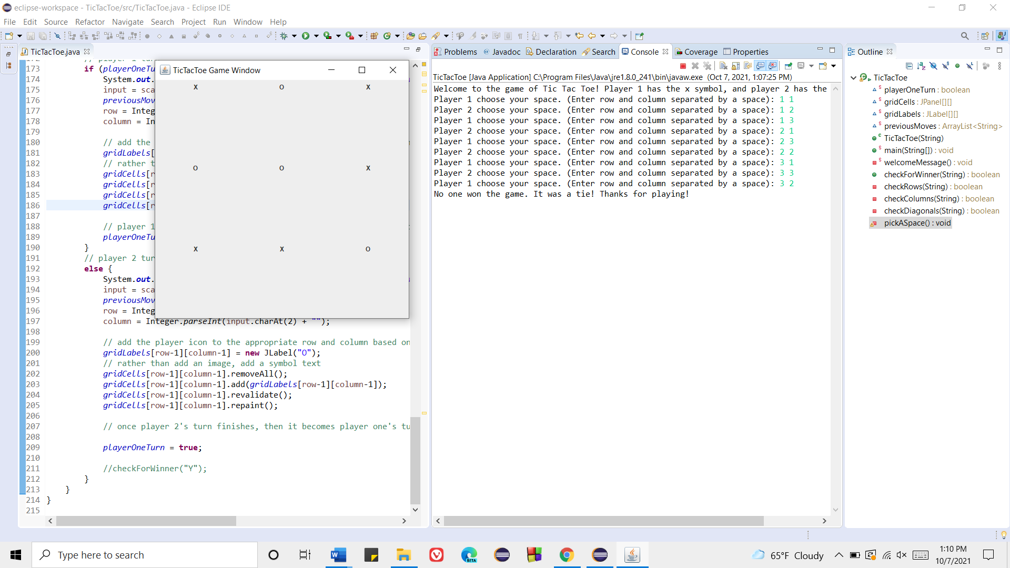This shows what happens in the event no one has won the game. The program states there has been a tie.